PLUGGING INTO THE FUTURE:AN EXPLORATION OF ELECTRICITY CONSUMPTION PATTERNS

INTRODUCTION

**India is the world's third-largest producer and third-largest consumer of electricity. The national electric grid in India has an installed capacity of 370.106 GW as of 31 March 2020. Renewable power plants, which also include large hydroelectric plants, constitute 35.86% of India's total installed capacity. During the fiscal year (FY) 2019–20, the total electricity generation in the country was 1,598 TWh, of which 1,383.5 TWh generated by utilities. The gross electricity consumption per capita in FY2019 was 1,208 kWh.**

**In light of the recent COVID-19 situation, when everyone has been under lockdown for the months of March to June the impacts of the lockdown on economic activities have been faced by every sector in a positive or a negative way.**

EMPATHY MAP

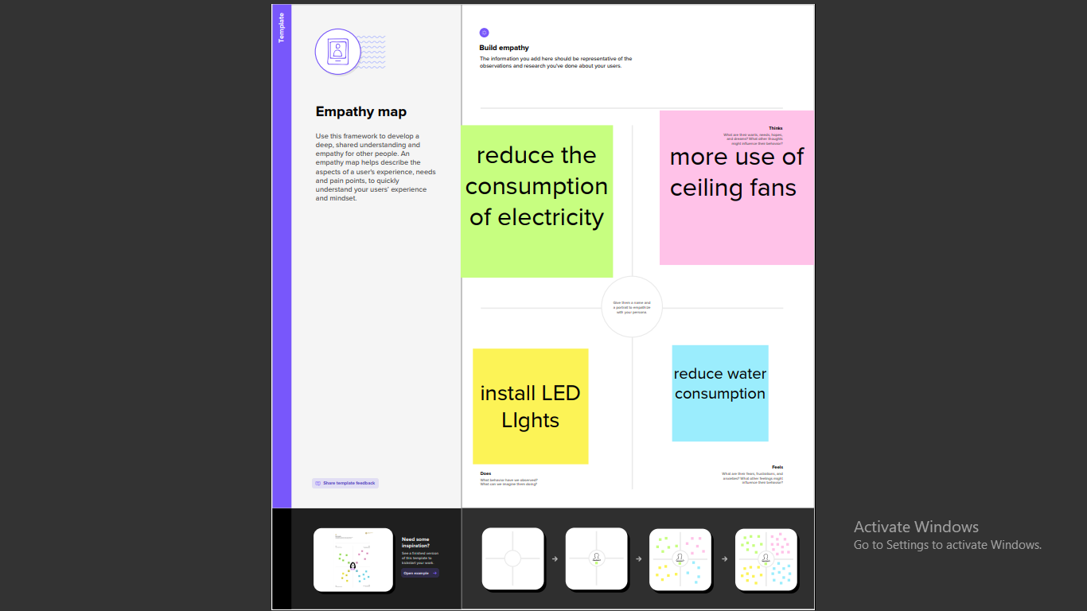

IDEATION AND BRAIN STORMING MAP

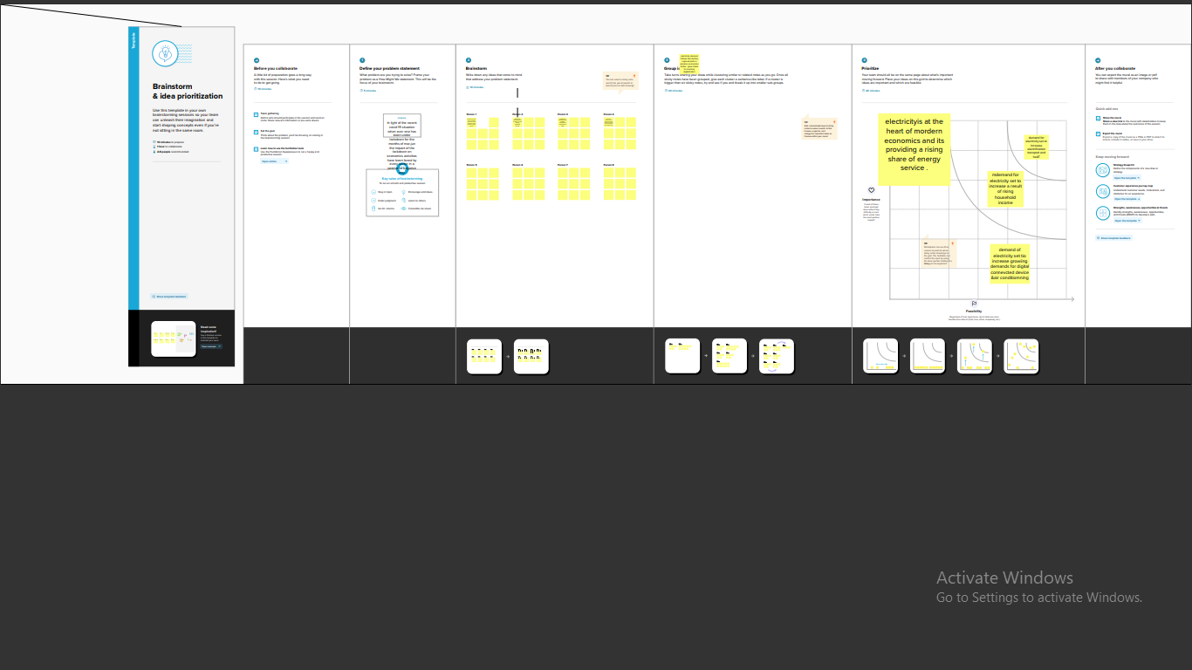



RESULT

* PEOPLE USE ELECTRICITY,
* Lighting
* Heating
* Cooling
* Refrigeration
* Operating application
* Computers
* Electronics
* Machinery
* Public transporting system

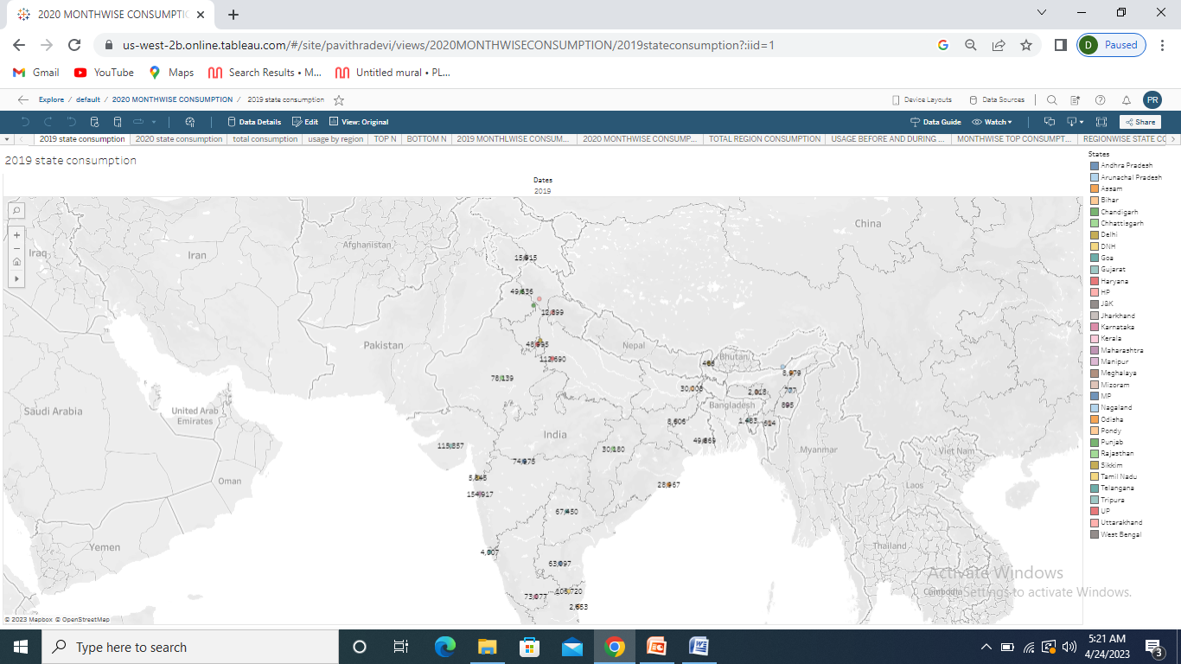

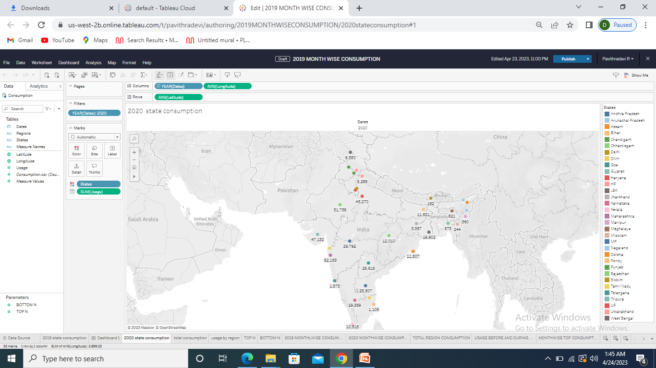

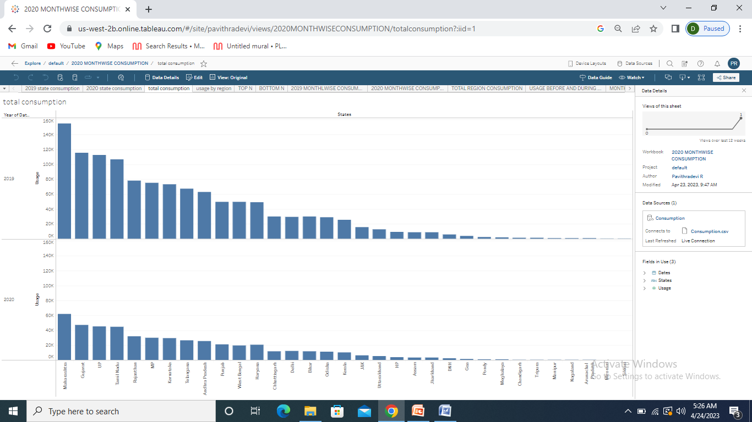

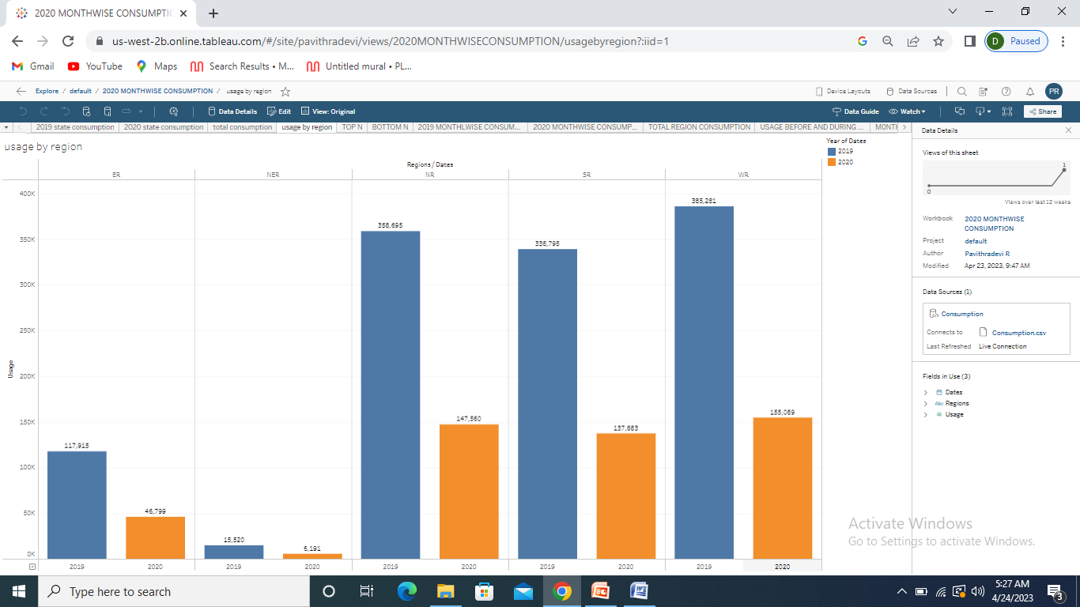

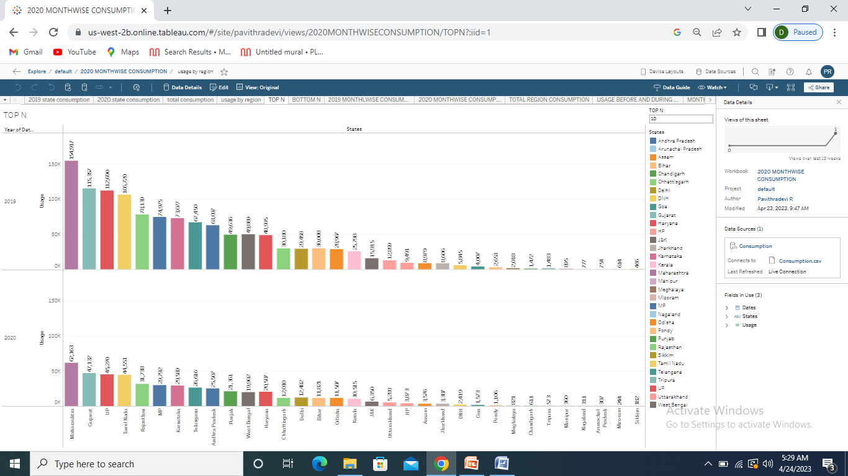

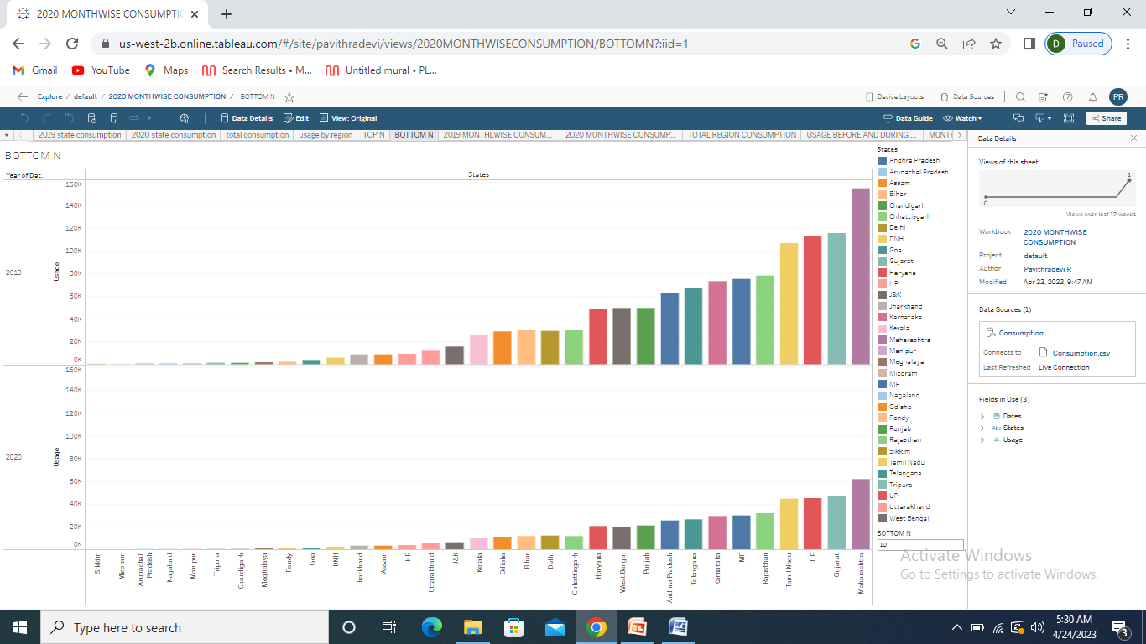

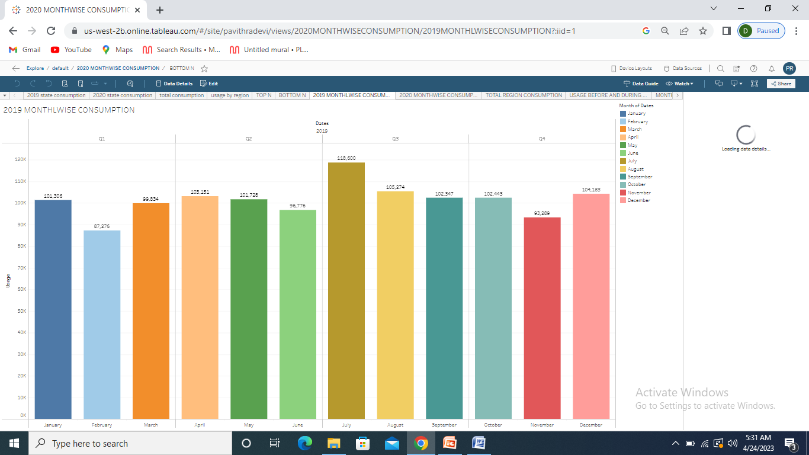

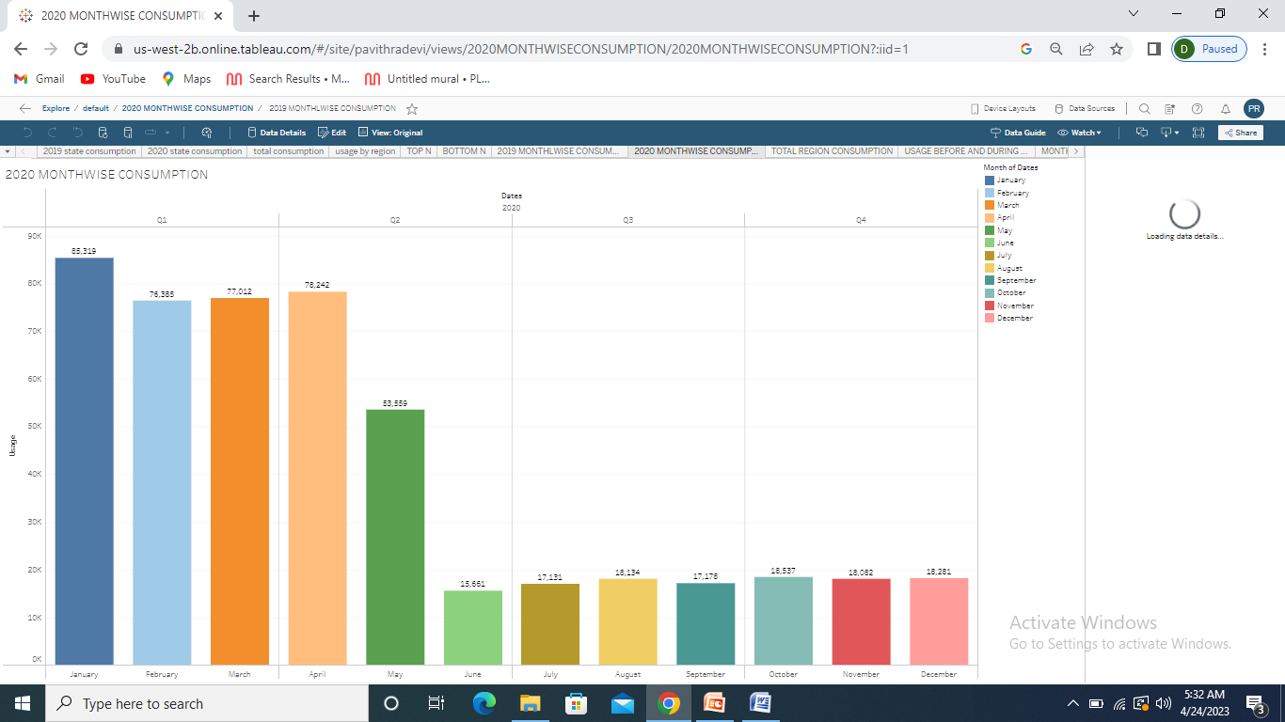

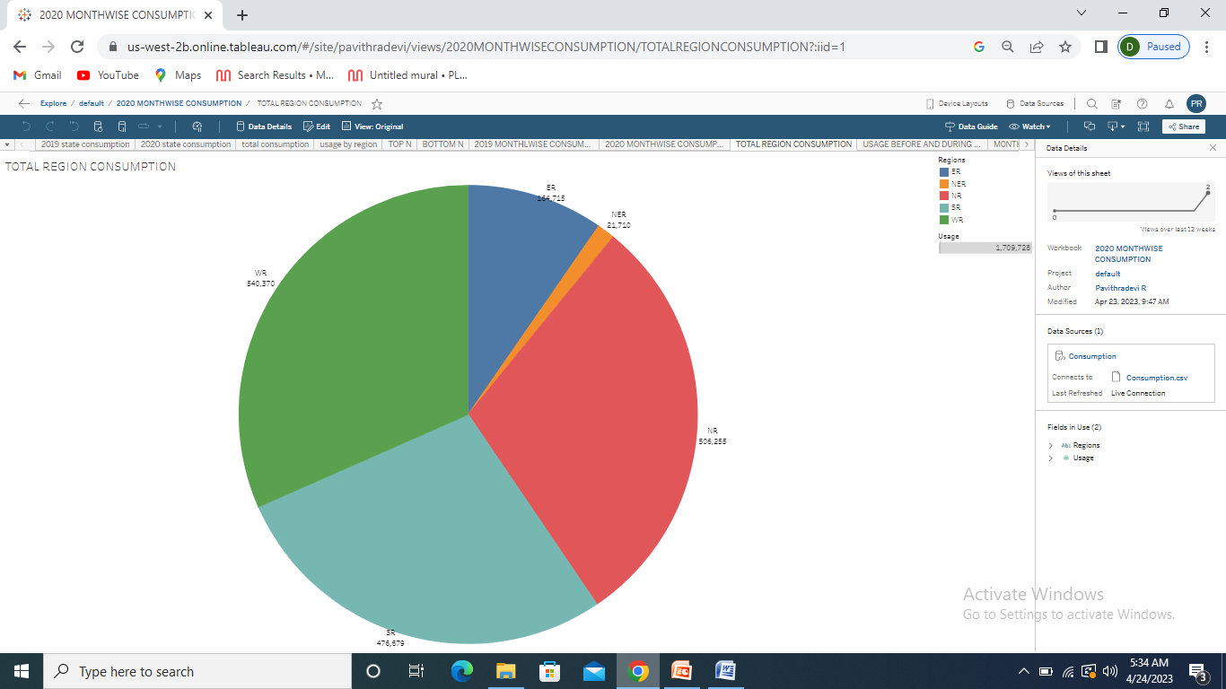

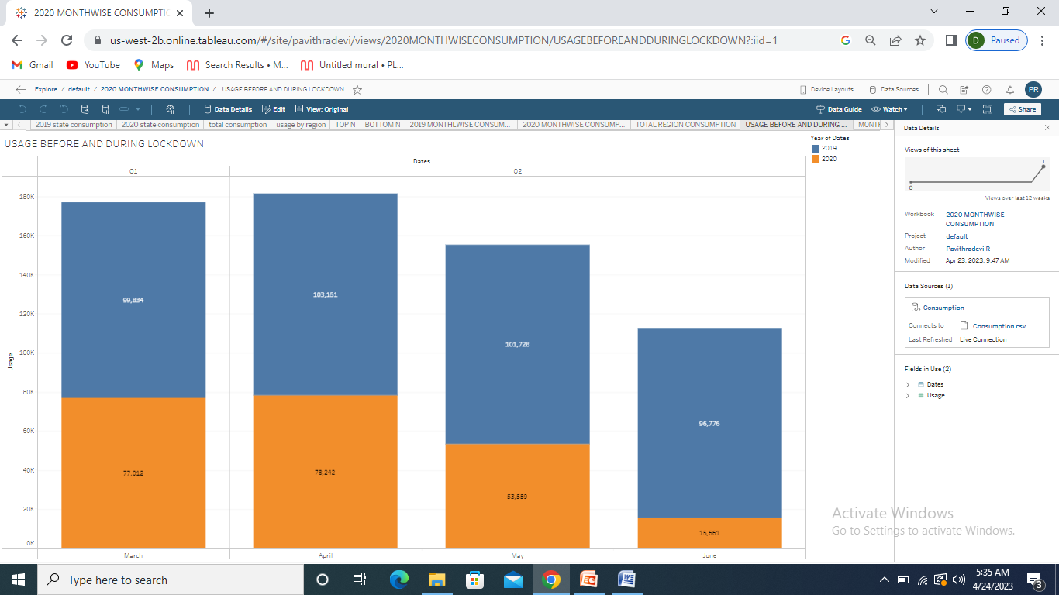

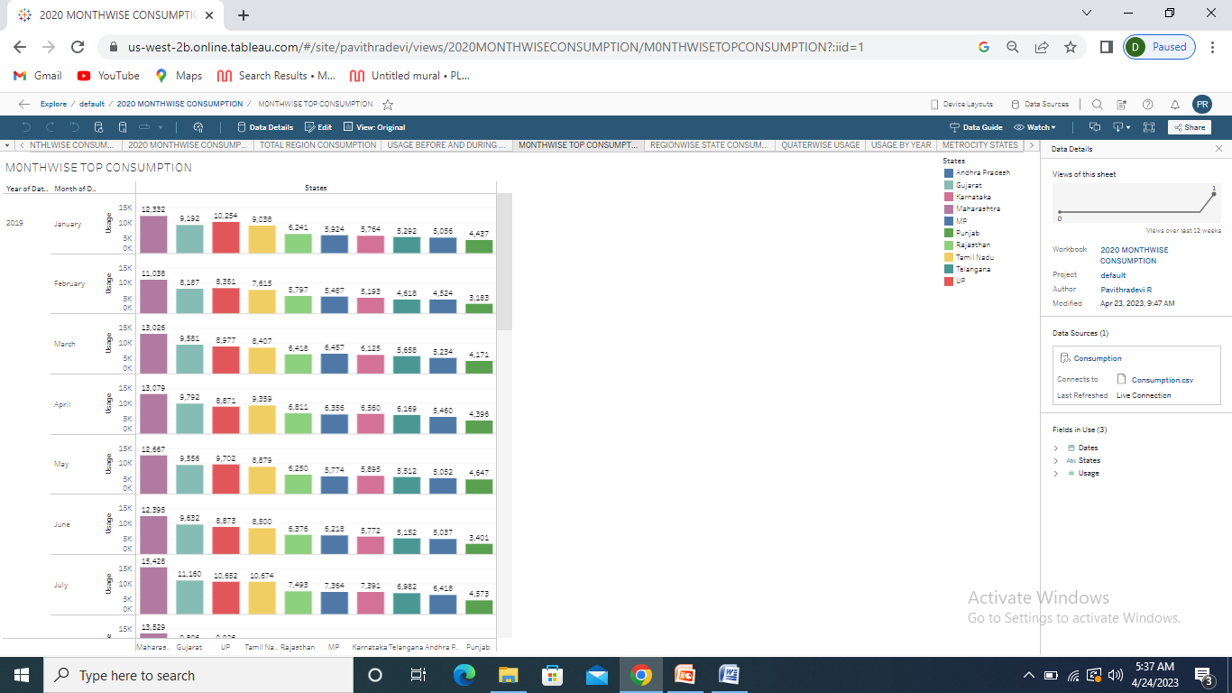

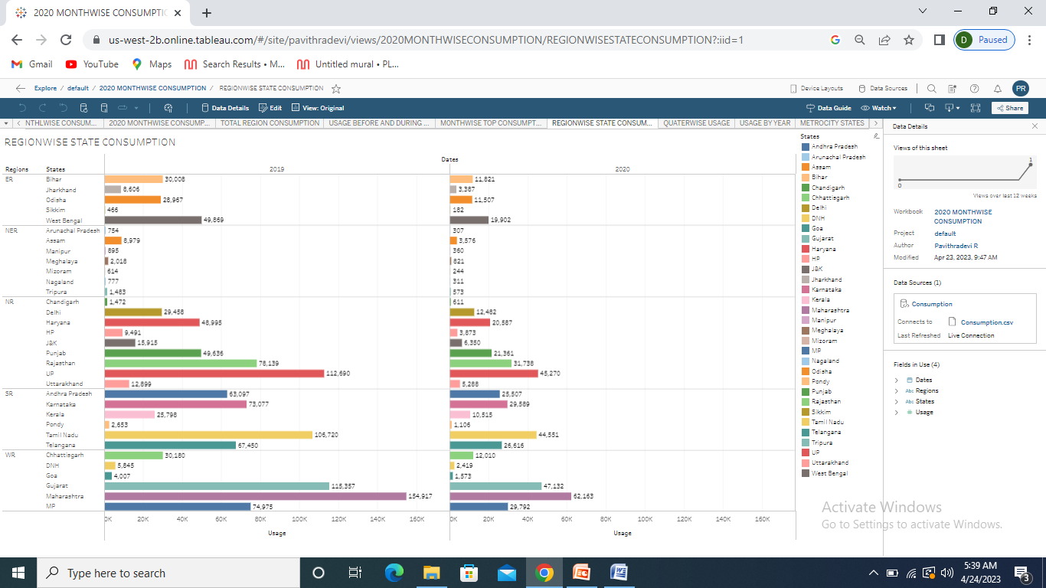

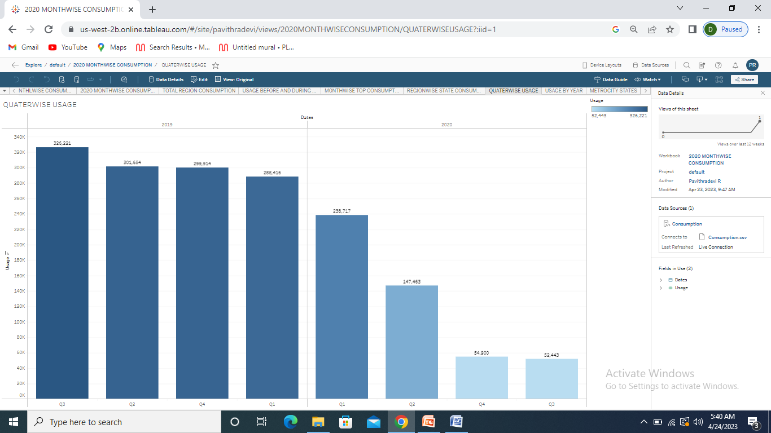

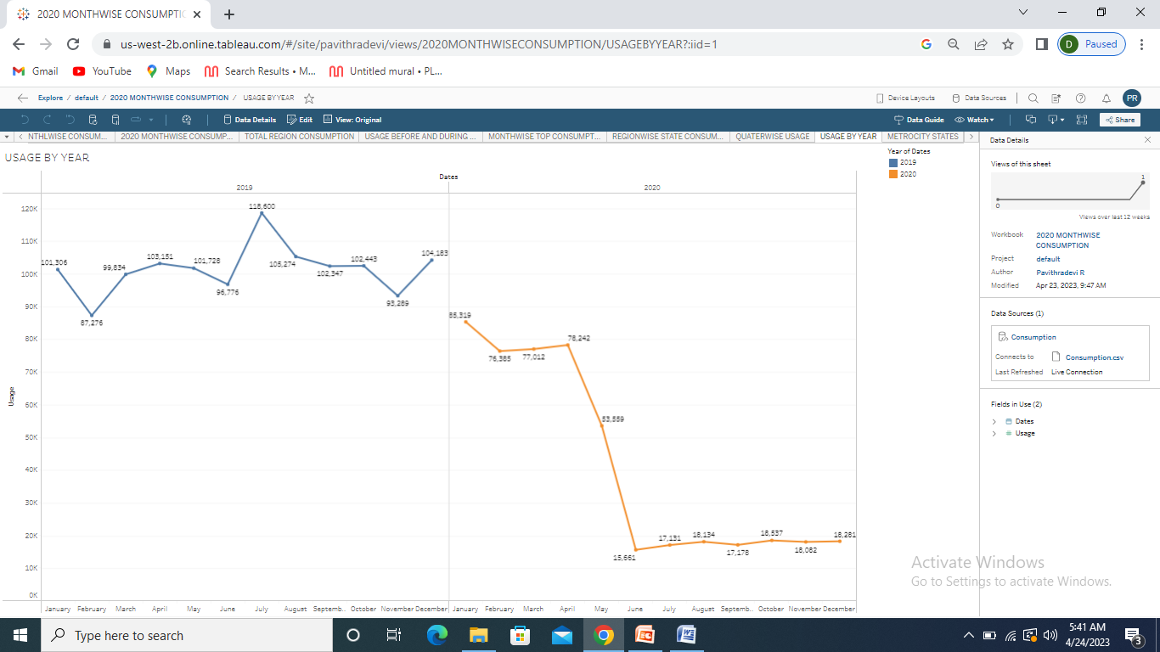

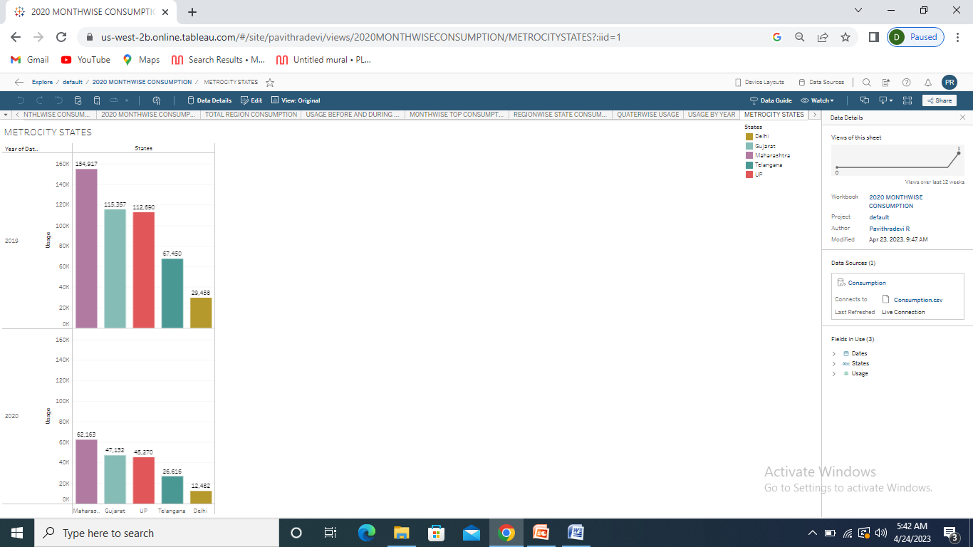

ADVANTAGE

The advantage of electric power is its reliable and uninterrupted supply runs the equipment efficiently and continuously. The transportation of electricity is easy once the transmission lines are functional. They work for years and need no or very less maintenance.

DISADVANTAGE

Over the long term, the rise in demand may place additional burdens on threatened environmental areas -- such as coastal areas or wildlife refuges -- to ensure adequate resources.Your overuse will contribute to a scarcity in this energy supply and thus an increase in overall electricity cost.

FUTURE SCOPE

In the Stated Policies Scenario, global electricity demand grows at 2.1% per year to 2040, twice the rate of primary energy demand. This raises electricity's share in total final energy consumption from 19% in 2018 to 24% in 2040. Electricity demand growth is set to be particularly strong in developing economies.

CONCLUSION

* electric energy consumption is energy consumption in the form of electrical energy about a fifth global energy is consumed as electricity ; for residential,industrial, commercial transportation and other purpose.
* Annual electricity consumption per capita serves as an important measure of a countries electric power development.